**US AVS migration Step by step guide**

Hi All,

Just a brief on this activity plan: we are migrating all VMs from US AVS 10.147.X.X ->To-> US AVS52 10.148.X.X. The key point is that we will not be changing the IP addresses of any VMs. We will create the destination network with the same name as the existing one, and we will retain the same IP CIDR. Once the final cutover sync and failover are completed, everything should work as expected without any interruption to the IP addresses or DNS records.

Kindly follow the stages listed below.

Stage:1

1. Create replication job as below:

Server Name: USA-VeeamMIG.sapiens.int

Add Source VM Resource Group (RG) for replication

Add the Source Network and Target network.

Stage 2:

Please notify the to the Business (email) Unit before the activity started.

Stage3:

Note: Set the maintenance in SCOM.

Shutdown the Replication RG VMs from the source vCenter side.

Stage 4:

Run the final Veeam replication job (Cutover), and then disable the job.

Stage 5:

Change the network segment on both sides of both AVS.

Note: Once the final replication is done, please inform the Israel team to make the network segment changes from the AVS side (This will be done by **Evgeny** or **Dan**).

screenshot is just for your reference:

Stage 6:

Run the Veeam 'Failover' on all the VMs by selecting the VMs—This will turn on the VMs.

**Note**: No need to manually turn on any VMs; Veeam Failover will take care of it.

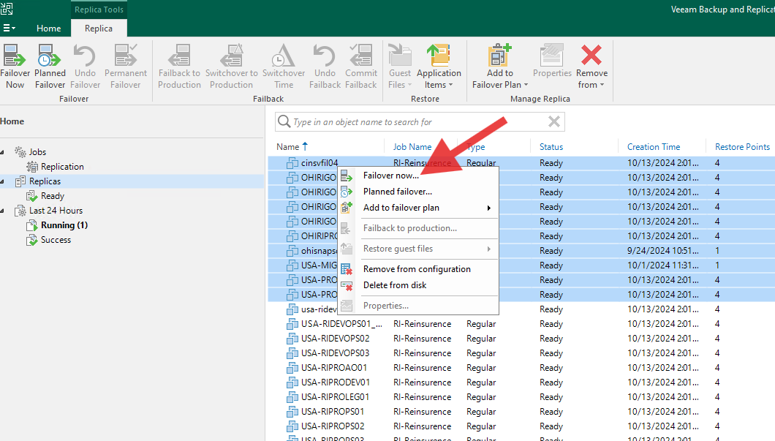

Stage 7:

Once the failover is done, all the VMs will automatically turn on. Please send an email to the BU to test the VMs.

Stage 8:

Wait for the BU confirmation email of testing successful, Delete Failover permanently will be done by **Micheal**.

**Note:** This will be deleting the replication snapshot on destination VMs. FYI.

Thanks,